Module Assembly - TopCoder NodeJS Active Client Challenge Costs API Deployment Guide

Revision History
Author | Revision Number | Date
isv | 1.0 | 03/29/2014

Deployment Instructions 3
1. Organization of Submission 3
2. Application Setup 3
2.1 Configuration 3
2.2 Build Scripts Setup 3
3. Database Setup 4
4. Deployment Instructions 4
5. Starting 4
6. Verification 4
7. Resource Contact List 7

Deployment Instructions

Organization of Submission

The submission follows directory structure provided below:

docs

Contains this document which is the Deployment Guide for the Module Assembly - TopCoder NodeJS Active Client Challenge Costs API assembly.

tc-api

Contains the configuration, libraries, sources for TopCoder Node JS API application developed/updated in the course of this assembly. This directory replicates the application development distribution structure and includes only updated and new files.

test_files

Contains the files with sample data ot be used for testing/review purposes only.

Application Setup

The submission is expected to be deployed to the following environment:

JRE 1.7
NodeJS 0.10.21
Informix DS 11.0
Git
Python 2.7.6
Heroku

This assembly was developed against following Git commit hash:

URL: https://github.com/cloudspokes/tc-api.git
Hash: 19c0fe29854f5c9974a277d7f38ea1870cf9d77c

Configuration

There were no configuration parameters defined by this assembly.

Build Scripts Setup

The TopCoder NodeJS API application provides the following commands which are to be used:

- npm install – installs TopCoder NodeJS API application
- npm rebuild – rebuilds TopCoder NodeJS API application
- npm test – runs Mocha-based unit tests.

Database Setup

No changes to existing database schema have been made.

Deployment Instructions

- Set up necessary infrastructure for TopCoder NodeJS API based on your environment See following page for details (click the link corresponding to your OS):
  - https://github.com/cloudspokes/tc-api/wiki/_pages
- Clone TopCoder NodeJS application from Git repository https://github.com/cloudspokes/tc-api.git to your local machine. See chapters suitable for your local environment at following page for details (click the link corresponding to your OS):
  - https://github.com/cloudspokes/tc-api/wiki/_pages
- Copy the code from tc-api directory of this submission into working copy cloned from Git repository at step above
- Set up environment variables to suit the current environment. See https://github.com/cloudspokes/tc-api/wiki/Configure-Environment-Variables
- Install TopCoder NodeJS API application using npm install command. See chapters suitable for your local environment at https://github.com/cloudspokes/tc-api/wiki/_pages for help (click the link corresponding to your OS)

Starting

- Install the TopCoder NodeJS API application
- Start ActionsHero server instance hosting TopCoder NodeJS API application (see Start Server chapter at page matching your current OS at https://github.com/cloudspokes/tc-api/wiki/_pages)

Verification

Before running the tests, please, set the current system date on machine where Informix server is running to 03/29/2014 because the test data provided sets the project phase timelines based on the current time on Informix server but
tc-api\test\test_files\expected_get_client_active_challenge_costs_1.json
and
tc-api\test\test_files\expected_get_client_active_challenge_costs_2.json

have expected values for date fields hard-coded on 03/29/2014

So if you'll run the tests on a different date like 03/30/2014 the dates calculated by report action will not match the hard-coded dates in .json files and tests will fail.

- Run the unit tests using command like:

node_modules/.bin/mocha ./test/test.reportsGetClientActiveChallengeCosts.js

The tests must be executed successfully:

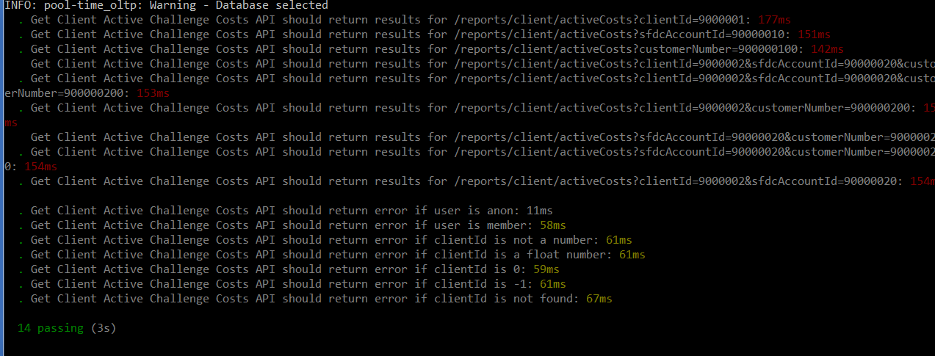

- Setup node-jslint tool using command like npm install jslint -g and check formatting for the updated code using commands like:

jslint --nomen actions\reports.js
jslint --nomen test\test.reportsGetClientActiveChallengeCosts.js
jslint --nomen routes.js

There must be no code formatting errors displayed:

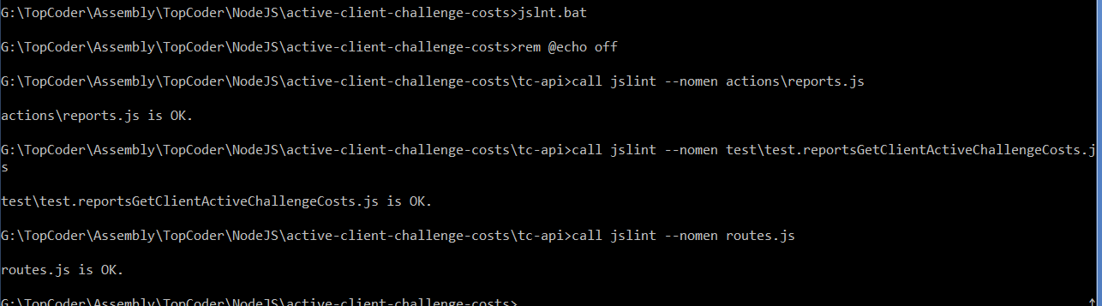

- Deploy application to Heroku by following the instructions at https://github.com/cloudspokes/tc-api/wiki/Heroku-Deployment-Guide

The application must be deployed successfully.

- To verify the API documentation, go to http://apiary.io, register and create own account, open Blueprint Editor and copy the content of tc-api/apiary.apib file from submission to editor and click Preview button.

The API documentation must be displayed successfully.

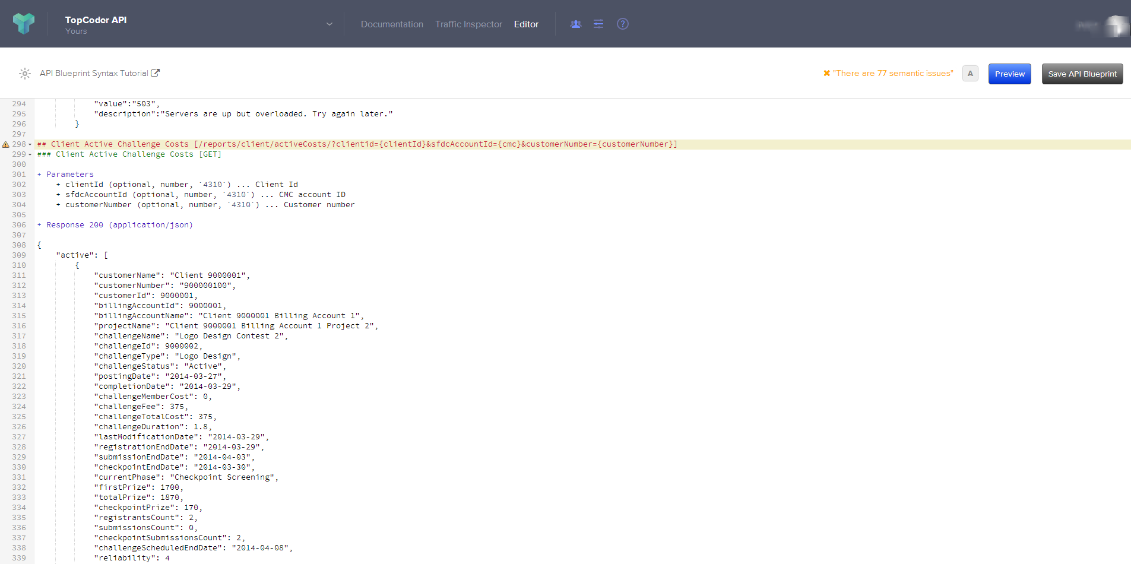

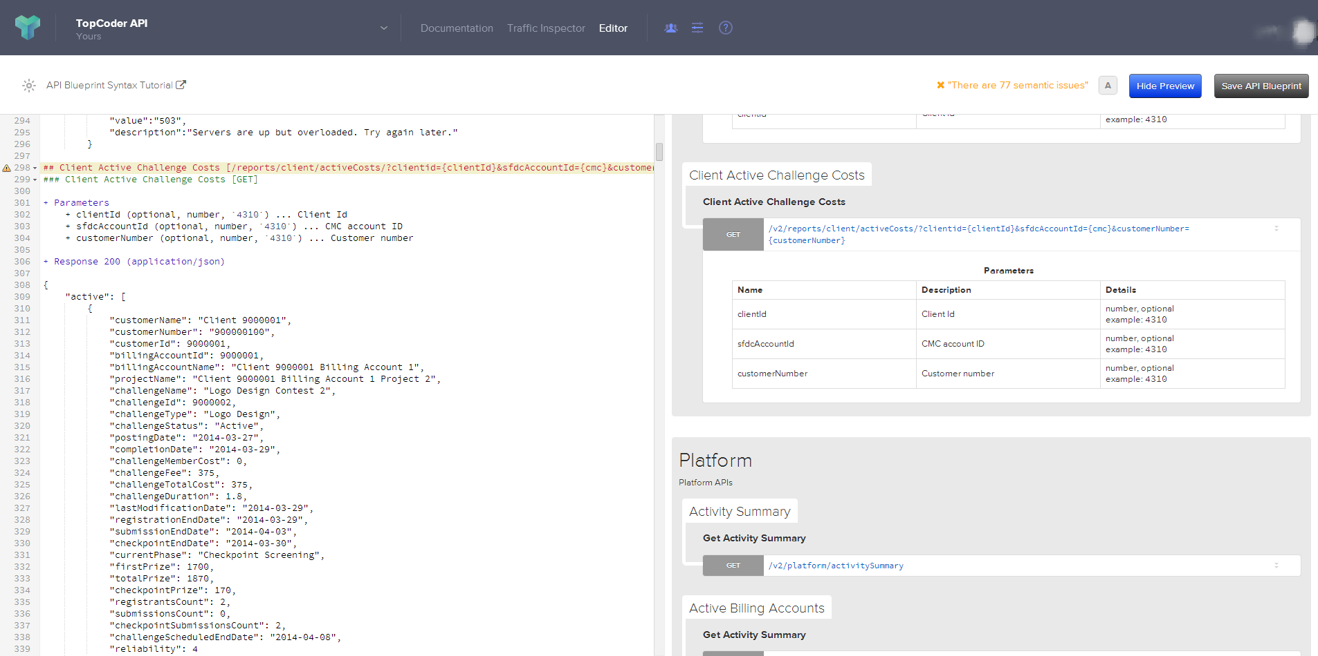

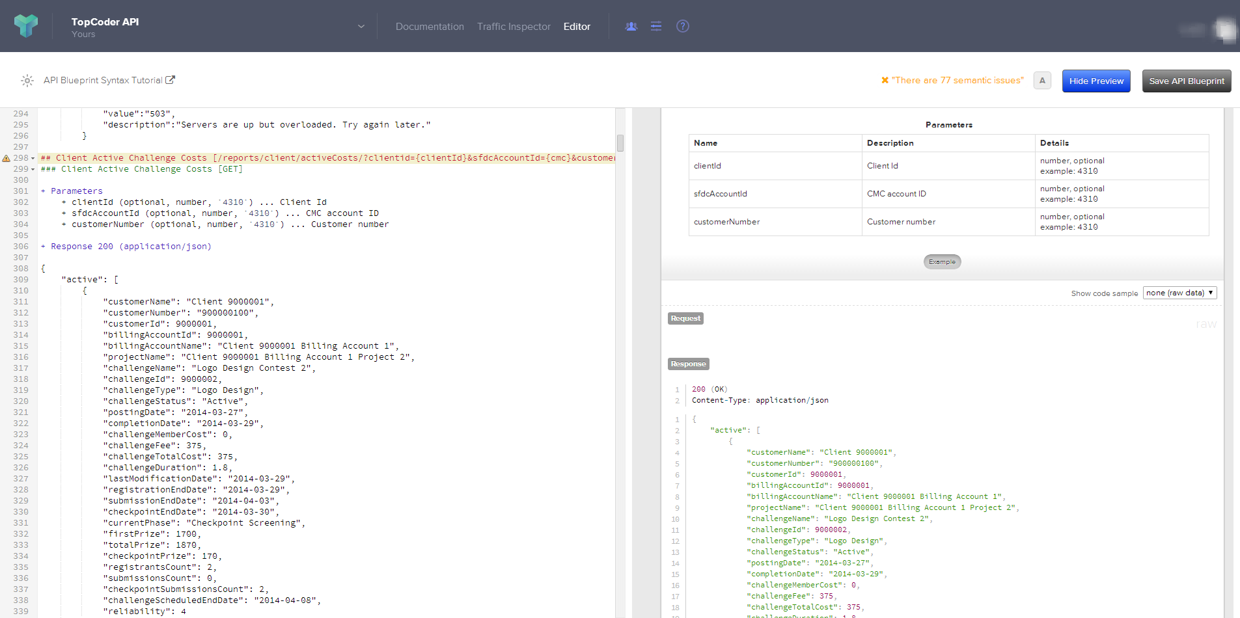

Resource Contact List

Name | Resource Email
isv

